



ECG Signals:

Ideal: 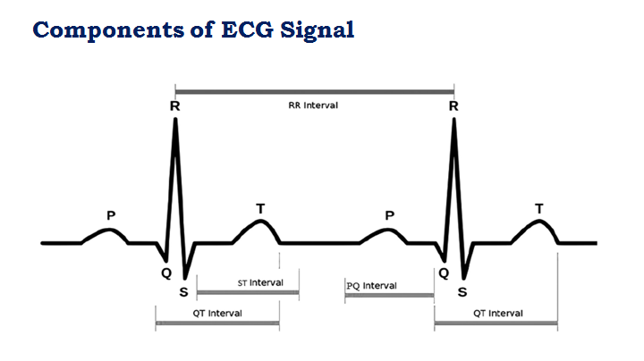

Real (Normal):

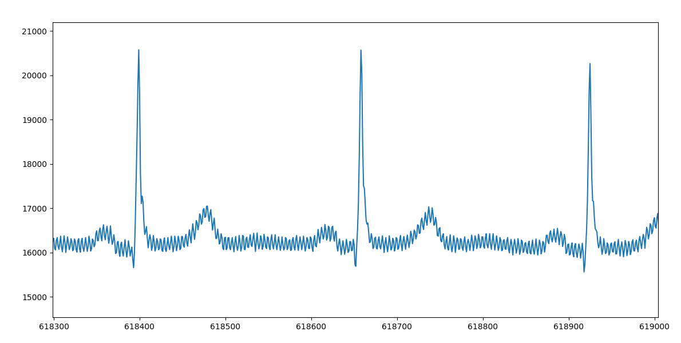

Real (Abnormal):

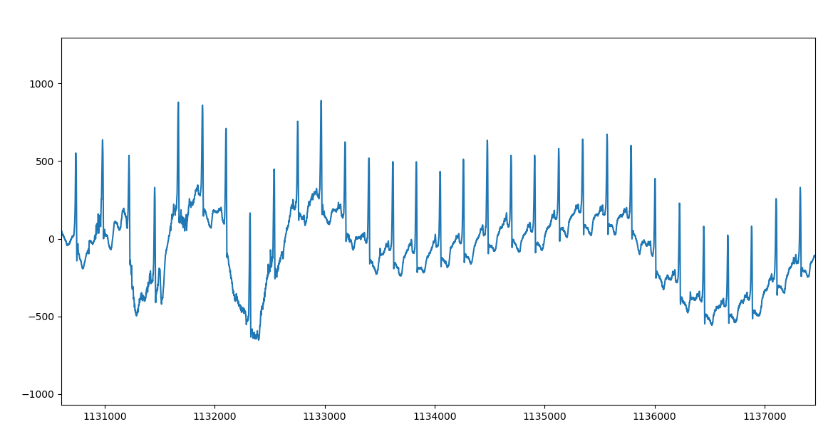

Image Processing:

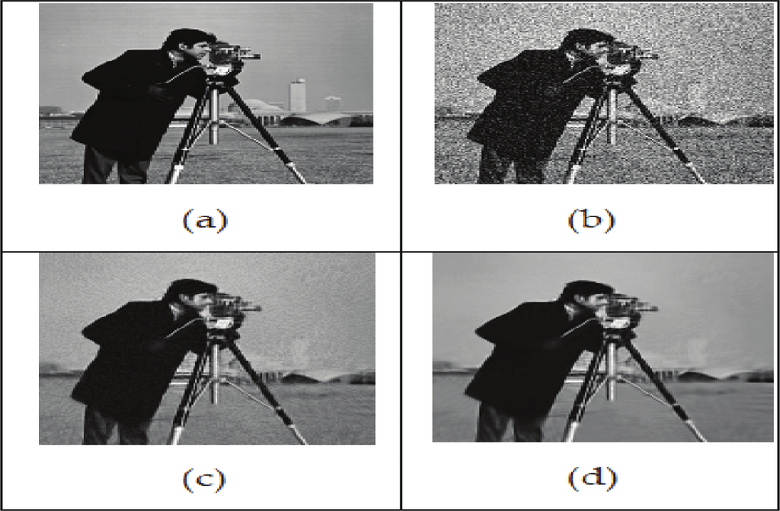

(a) Clean image (Cameraman), (b) Noisy image, (c) The denoised image and (d) better denoised image.